DATA ASSIGNMENT 3 - MEMO

To: Supervisor
From: Ben Widgren
Date: April 2026
Subject: The Effect of County-Level COVID-19 Mortality on Housing Prices in 2021

1. Introduction
This memo explores how initial COVID-19 mortality rates from 2020 affect housing prices the following year of 2021. The COVID-19 pandemic was a shock to the world that had deep effects at the household level, thus this question is of economic and policy interest. The COVID-19 pandemic visibly and tangibly disrupted labor markets; this analysis aims to discover whether the pandemic also shocked the housing market. This analysis does not make any economic or policy-related suggestions, but rather seeks to establish the groundwork for providing data-driven analysis that may be of use in such discussions.

2. Data
A few different sources of data were used in our analysis.
- The data source containing COVID-19 cases and deaths came from the New York Times, who compiled day-by-day totals of COVID-19 cases and deaths at the county level, resulting in each county in the USA having a cumulative total of COVID-19 cases and deaths by the end of the year.
- To normalize mortality numbers to per-capita mortality rates, data from the U.S. Census provided county-level population figures for each county so total COVID-19 mortality rates from each county could be compared with one another.
- To obtain housing price information in 2020 and 2021, a 3-digit level ZIP dataset from the Federal Finance Housing Agency (FHFA) was used; the HPI for each 3-digit ZIP code in 2020 is used as a control for the analysis, while 2021 HPI figures are evaluated for any inflated or deflated changes due to COVID-19 mortality rates in corresponding geographical areas.
- Due to the FHFA dataset only containing 3-digit ZIP level records rather than 5-digit ZIP level data, a ZIP-county crosswalk dataset from the U.S. Department of Housing and Urban Development’s Office of Policy Development and Research was used to aggregate the 3-digit ZIP codes to their respective counties. Although this does introduce a degree of approximation the data, it does not in any way invalidate the analysis made.
A process of cleaning and aggregating data from these data sources yielded a final dataset consisting of several variables of interest at the county level…

- AnnualChange2021 – annual change in HPI from 2020 to 2021
  - Our main variable of interest - represents the change in HPI in a given county during COVID-19 from 2020 to 2021
- County-level per-capita COVID-19 Mortality Rates – deaths per 100,000 people
  - Our main predictor in this analysis – the “per 100,000 people” form is better for signaling magnitude
- AnnualChange2020 - annual change in HPI from 2019 to 2020
  - Pre-COVID-19 pandemic change in HPI in a given county, and as such serves as a control in the analysis

Summary Statistics

Table 1. Regression Variables — County-Level, 2020–2021
Statistic | COVID Mortality Rate (per 100k) | HPI Annual Change 2021 (%) | HPI Annual Change 2020 (%)
Observations | 734 counties | 738 counties | 738 counties
Mean | 103.47 | 11.15 | 3.63
Median | 90.42 | 11.00 | 3.64
Std. Dev. | 71.82 | 3.76 | 1.89
Skewness | Right-skewed | Approx. symmetric | Slightly left-skewed

Note: Mortality rate is deaths per 100,000 residents.

Table 2. County Population Estimates, 2020 (Census)
Statistic | Value
Observations | 739 counties
Mean | 292,807
Median | 71,830
Std. Dev. | 635,535
Min | 1,185
Max | 9,943,046
Skewness | Strongly right-skewed (7.20)

Note: Population is reported in persons

Key Variable Visualizations
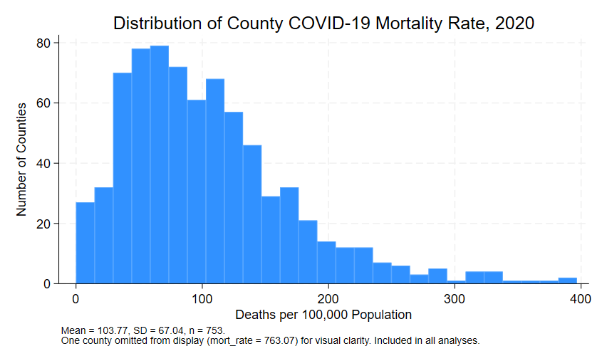
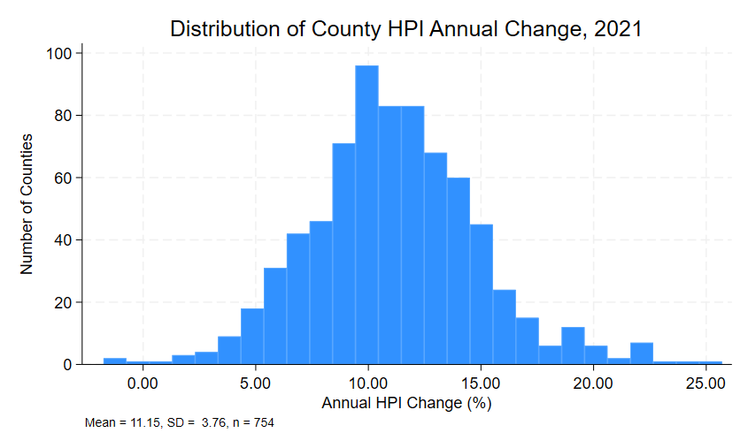

3. Empirical Analysis

Empirical Strategy
As was briefly described above, the empirical strategy to transform the available datasets to a form that fit our regression specification, approximation of 3-digit ZIP codes to county FIPS codes was necessary. The ZIP crosswalk data from HUD was used to accomplish this, and due to 3-digit ZIP codes covering fairly large areas, they tend to match up with counties; whenever multiple 3-digit ZIP codes mapped to the same county, the ZIP code with the highest residential ratio was used to represent that county.
After transformation, each county with its COVID-19 deaths, population figures, and HPI data could be used in this regression model:

$${Annual_HPI_Change2021}_{i}=β_{0}+β_{1}{MortalityRate}_{i}+β_{2}{Annual_HPI_Change2020}_{i}+ε_{i}$$

This regression model clearly makes some assumptions, which are outlined below.

Causality
For this model to estimate causality between COVID-19 mortality rates and housing prices, we first address a simple assumption: there is no reverse causality. This is accomplished by construction; HPI indexes in 2021 could not cause more or less COVID-19 deaths in a particular county in the year 2020.
Our second causality assumption requires more defense: the inclusion of 2020 annual change in HPI is defending the assumption that besides COVID-19 mortality rates, counties were on similar trajectories for changes in housing prices going into 2021, so that the main factor causing divergence in housing prices were COVID-19 mortality rates. Including 2020 annual change in HPI can account for any trends that existed in a county before the COVID-19 pandemic.

Results
We first report the numerical results of the analysis in the table below.

Table 3. OLS Regression — Dependent Variable: HPI Annual Change, 2021
 | Coefficient | Std. Error | t | 95% Conf. Interval
Regressors
COVID Mortality Rate | −0.0072 | 0.0015 | −4.70 | [−0.0102, −0.0042]***
HPI Annual Change, 2020 | 1.1085 | 0.0596 | 18.59 | [0.9914, 1.2255]***
Model fit
Observations | 750
R-squared | 0.3399
Note: *** p < 0.001. Dependent variable is the FHFA house price index annual percentage change at the county level for 2021, approximated from 3-digit ZIP codes via HUD crosswalk. COVID mortality rate is cumulative 2020 deaths per 100,000 residents (Census). HPI Annual Change 2020 included as a pre-pandemic baseline control.

A scaled-up interpretation of the results follows:
- 100 additional COVID-19 deaths per 100,000 people in a particular county predicted a 0.72 percentage point decrease in HPI in 2021
In other words, more COVID-19 deaths in 2020 predicted lower housing prices in 2021.
Although this analysis does not and cannot specify the mechanism that decreased housing prices due to COVID-19 mortality rates, two possibilities are worth considering…

- More available households – if a county experienced higher deaths, then more households become vacant and thus available for purchase, and by the simple laws of supply and demand, higher housing supply would put downward pressure on housing prices
- Decreased demand in high-death counties – by the same laws of supply and demand, if a higher COVID-19 mortality rate in a county dissuades homebuyers from buying in that county, then the demand for housing would decrease, putting downward pressure on housing prices in that county

To briefly note, the positive, near-1 in magnitude coefficient on 2020 Annual HPI change reflects the notion that housing markets exhibit momentum – if a housing market in a county was experiencing HPI growth in 2020, then it was predicted their HPI would growth at about the same rate or potentially slightly more in 2021.

4. Conclusion
The analysis suggests that higher mortality rates due to COVID-19 at the county level in 2020 is associated with lower housing prices in said county in 2021, with speculation that the mechanism being the increase of purchasable homes and/or decreased demand for housing in high-mortality counties.
Because the data was approximated with 3-digit ZIP codes to county level assignment, our county-level housing price data is also approximated. While this approximation reduces the precision of our estimates, it does not invalidate them.
Further on the topic of estimate precision, one limitation of this data is that it does not account for the migration of remote workers created due to the pandemic. Other data suggests the phenomenon that the widespread shift to remote work, particularly high-value work in dense urban areas, allowed newly remote workers to relocate to lower-density areas; these other data also suggest that these lower-density areas had higher COVID-19 mortality rates for various reasons, such as higher proportions of elderly population, or longer distances to immediate healthcare. This suggests an opposite effect from this analysis, namely that remote worker migration would increase housing demand in high-mortality counties, thus putting upward pressure on housing prices.
However, this uncaptured effect notably suggests that the effect of high COVID-19 mortality rates may have a stronger negative effect than concluded from this analysis - if remote worker migration puts unaccounted upward pressure on housing prices, yet this analysis still concluded a negative effect, then we would expect an even more negative effect if we imagine no remote worker migration.
For further and more precise analysis that includes this remote worker migration effect, it would be useful to account for the changes in population in particular counties from 2020 to 2021 and include that in the regression. Further data that details change in population due to migration would be even more potent for analysis and allow for analysis that is closer to the true effects of the COVID-19 pandemic on housing prices.

